Trabajo Practico – Herramientas Computacionales

Estudiante: Elard Amaya

Quiz 1 – Phyton Variables

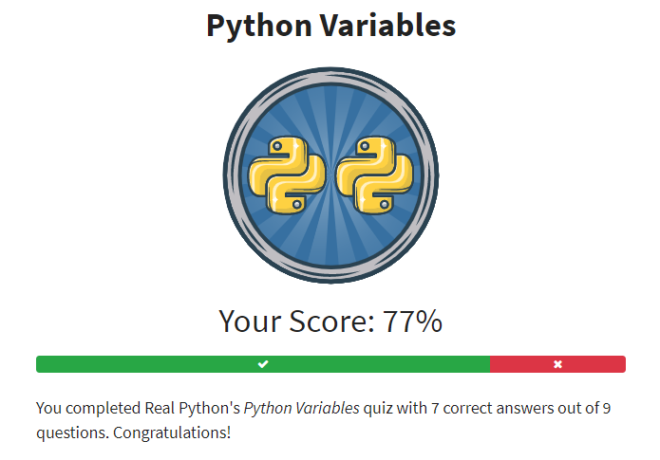

Quiz 2 – Phyton Operators and Expressions

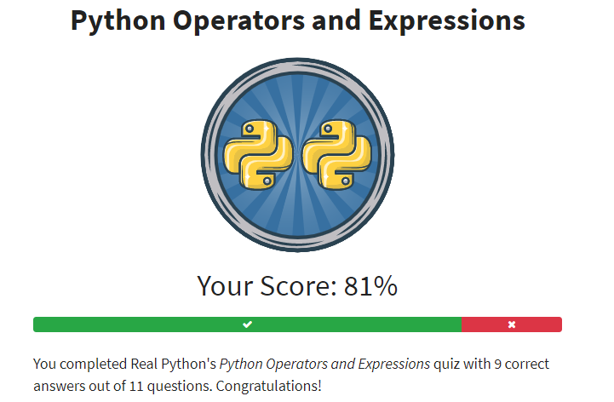

Quiz 3 – Phyton Conditional Statements

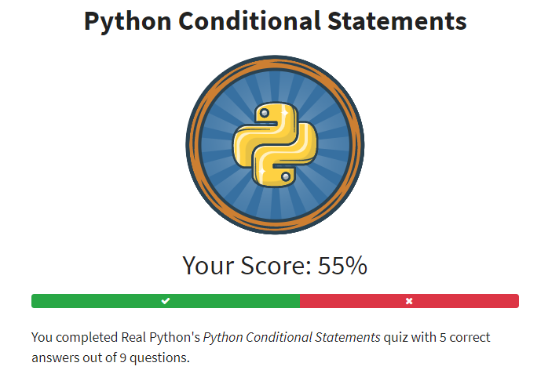

Quiz 4 – Phyton Strings and Characters

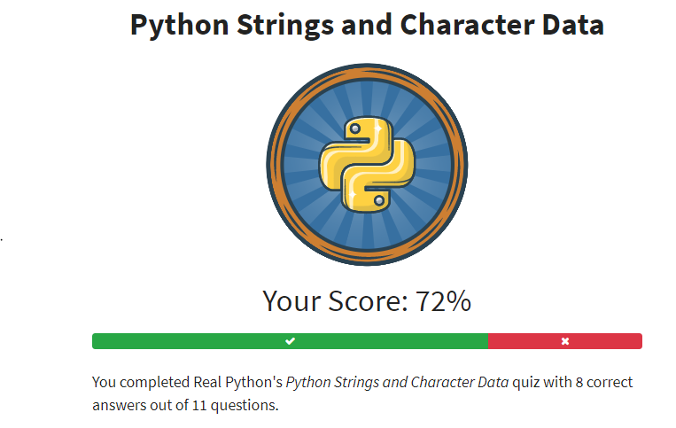

Quiz 5 – Phyton List and Tuples

